IEEE GRSS Certified Education and Training (CET) Series

Webinar Lecture Series Proposal Template

|  |  |
| --- | --- |
| **Name(s):** |  |
| **Email(s):** |  |
| **Affiliation(s):** |  |
| **Biography:** | |
| (Please write a short self-introduction for us and the viewers to better understand your background and expertise. Please also include your photo as this will be used in the promotion of the webinar. If there are multiple speakers, please prepare an introduction and photo for each speaker.) | |
| **Title of lecture (series):** | (Please provide the title for your lecture series.) |
| **Lecture description:** | |
| (Please write an abstract describing the contents of the lecture. Limit to 300 words.) | |
| **Learning outcomes:** | |
| (Please provide a description of the main takeaways for viewers after participating in the lectures. Limit to 300 words, preferably in bullet list.) | |
| **Content outline:** | |
| (Please prepare an outline showing the general structure and flow of the lecture, clearly indicate how the content is divided across the sessions. If there are multiple speakers, please also indicate who will be speaking for each session.) | |
| **Live webinar schedule:** | |
| (Please provide the dates when you are available to deliver the live webinar lecture(s).) | |
| **CEU materials:** | Will you provide the test materials for an exam or assignment: Yes or No. If yes, please prepare the exam or assignment with the webinar after the proposal has been approved. |

Please send the completed webinar proposal form to the following email address:

grss-webinars@ieee.org

Reminders:

1. One live webinar session is expected to be 30-60 minutes in length. One lecture series may be composed of 2-3 live webinar sessions.
2. If there are multiple speakers, the speakers may be distributed across sessions in the lecture series. For example, a single webinar session may be subdivided into sections with a speaker delivering the lecture for each section.
3. The webinars should be designed as educational lectures. You may choose to include your own research outcomes in the lecture but these should be limited to be supporting material for the lecture topic.
4. Participants may choose to apply for IEEE Continuing Education Units (CEU) after the webinar. This will be awarded to them upon completion of an exam or assignment covering the contents discussed in the webinar. We will appreciate it if you also provide exam material in the form of either test questions or practical applications.

Webinar production process flow:

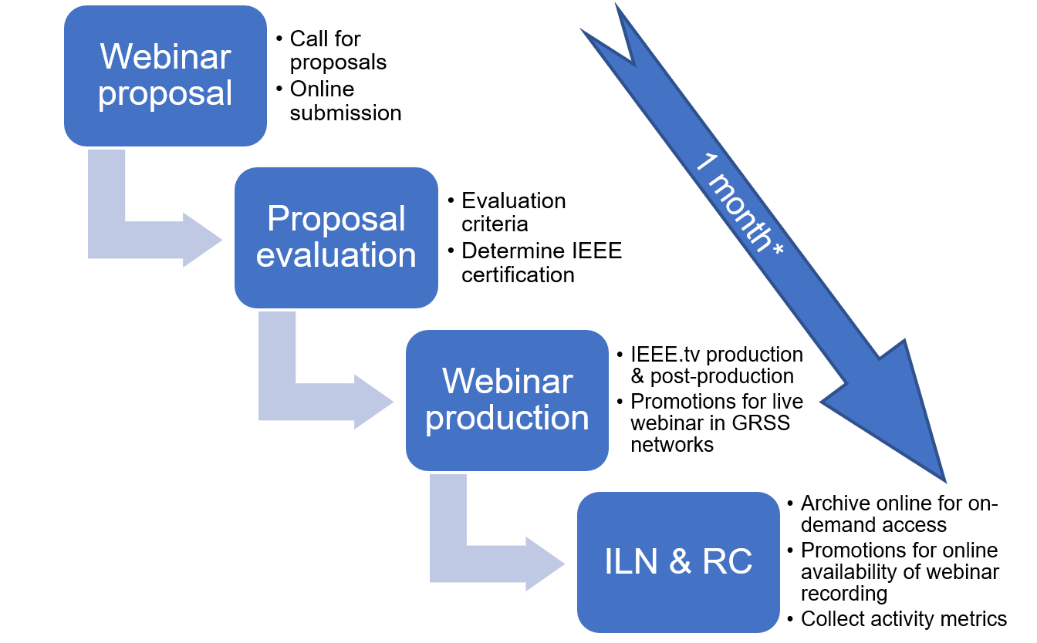

The time allotted for the production of the webinar is approximately 1 month after the notification of acceptance by the evaluation committee. The speaker is expected to provide the training content while IEEE.tv will be involved with the production of the audio-visual material. After IEEE.tv has provided the webinar link, the webinar series will be announced two weeks before the live broadcast and recording. Subsequently, the webinar will be archived online on the GRSS Resource Center (RC) and IEEE Learning Network (ILN) and an announcement will be made when the webinar recording is available for on-demand access. Test materials will be distributed at the end of a lecture series and participants will have the option to pass an exam if they wish to obtain IEEE CEUs.

The promotion of the webinar will include the lecture title, the speaker biography, and a description of the lecture. IEEE.tv staff will host the webinar during the live broadcast with the speaker. After delivery of the webinar, participants may take an exam or submit an assignment if they are applying for certification. Post-production of the webinar will also be handled by IEEE.tv and the webinar will then be archived online on the GRSS Resource Center and IEEE Learning Network for on-demand access.

If you have further questions, please send an email to grss-webinars@ieee.org and we will address your inquiries. Thank you for considering our invitation!